Beacon’s Blogging Process

- Research Blog Topics (Adrienne responsible)
  - Research topics for each client for the month on the last week of the month previous
  - Use resources like Answer the Public and Google Keyword planner to come up with relevant topics
  - Talk to account manager about items the client wants to promote or that would support a social media focus for the month
  - Research to see if there are any “national days or weeks” that relate to the industry (i.e. National Foster Care month, National Earth Day, etc.,)
- Assign blog topics in Teamwork (Adrienne responsible)
  - Each blog should be a sub-task under the main “blogging” task for the month.
  - Write the blog title/subject in the sub-task line
  - Choose a due date for the blog

Writing & Posting Process
- Keyword research
  - Use Google Keyword Planner
  - Look for medium to low competition words with highest search numbers
  - Pick 2-3 to focus on in the blog
- Research topic
  - Make sure to have at least 3 blogs as reference material, 5 is better
  - Reference material should come from reputable sources, double check with Adrienne if not sure is source is reputable.
  - Do NOT plegerize material from blogs. Rewrite material in your own words.
    - Using a “quote” from another blog is ok so long as it is designated as a quote, the source is clearly stated in the blog, and it is linked back to the source
  - Do NOT use blogs from local competitors as reference material
- Write Blog
  - Blogs should be written in the client’s WordPress area, on their website
  - Use keywords in natural flow of the text throughout the blog. Try to work into the first paragraph if possible.
  - Use sub-headlines with keywords to break up text. (See first screen shot) 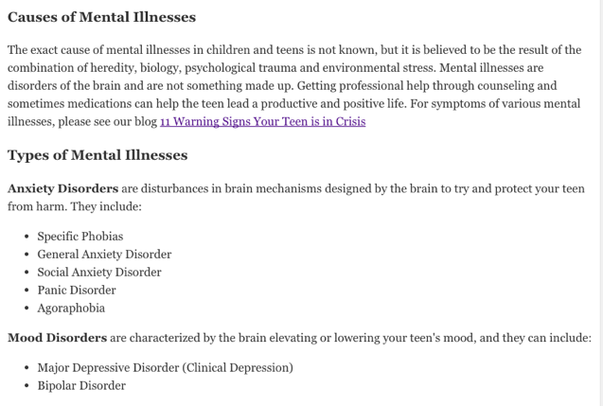
    - Make sure sub-headlines are not just bold, but you are using the “heading” options in the drop down at the top of the WordPress document. (See second screen shot below) 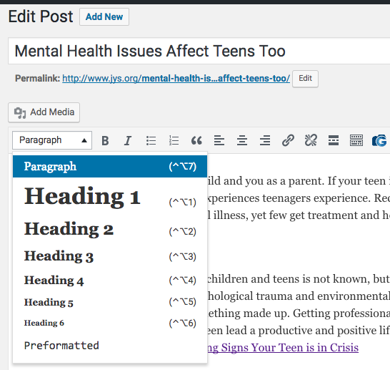
  - Break up text with bullet points, lists, graphs, info graphics, photos, bold text etc.
  - Blog structure: Intro, body, conclusion
    - “First tell them what you’re going to tell them, then tell them, then tell them what you just told them.”
    - The intro should be one to three sentences and summarized what the blog is going to be about.
    - The body is the bulk of the blog
    - The conclusion is a summary of what the main point of the blog with a gentle call to action and a link back to one of the client’s services or products page.
  - Required Links
    - Each blog should have 1-3 relevant links back to the client’s website.
    - 1-3 backlinks to other people’s material is acceptiable. However the links must be to neutral parties. Meaning it if the blog is for a florist in Anchorage, we do not want to link to another florist’s blog, even if they are across the country. It would be better to link to a nursery that offered tips on caring for plants.
- Posting Logistics
  - Once blog has been written, it must be checked using Grammerly for grammer and spelling.
  - A photo needs to be chosen from Shutterstock. Provide Ricky or Sarah with the Shutterstock number and they will download the photo.
    - DO NOT use any photo accept those provided by the client, or taken by our staff, or from Shutterstock.
    - Upload the photo as the featured image for the blog 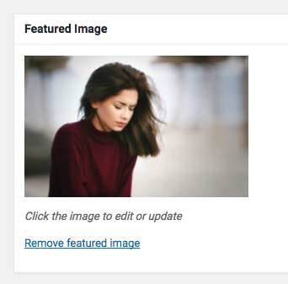
    - When uploading the photo, copy the title that comes with the photo to the “description” area, retitle the photo with a description of the photo. Then put the blog title in the “Alt Text” area. 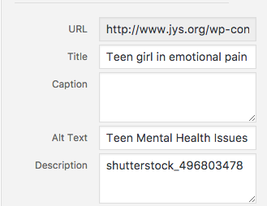
  - SEO Items
    - Edit the Permalink and remove any connceting words like a, the, to, for etc.
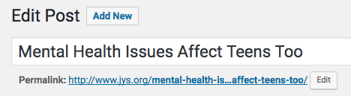
    - Select the appropriate categories. Make sure that “uncategorized” is not checked if it is available.
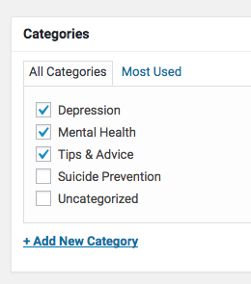
    - Add in blog title in the SEO section at the bottom on the blog.
      - Make sure title does not exceed 60-70 characters even if that means you have to shorten the title
    - Add in a brief summary of the blog, not to exceed 160-70 characters. Think “what would make someone want to read this blog?”
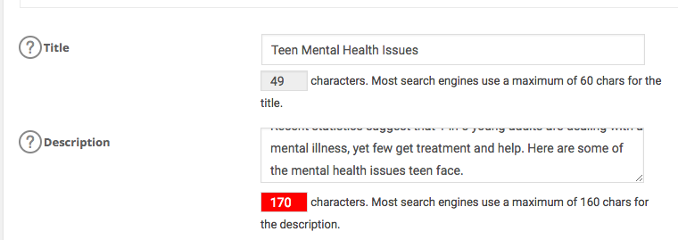
  - Send blog link to Adrienne Wilkerson for review via TeamWork.
    - Make edits if needed
  - Publish blog
  - Post blog link in Social Media Edits Slack channel for whichever social media contractor needs to post it.

