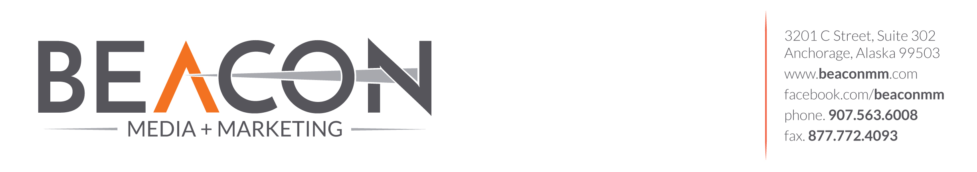

Client Profile

For

CONTENT STRATEGY
In this section we want to learn who you are and where you would like to go. This will allow us to better understand your business and customer.

Who Are You?
Who are you and what does your company do?

Why did you start this company?

Who are your customers?
Male or female, age, ethnicity, demographics, location, influencers, decision-makers, etc.?

What is your current goal?
You've come to us to market your business, so what specifically are you trying to achieve? What sectors of your business are you looking to grow?

Mission statement and values
What is your mission statement? What are your company values?

Competitive Assessment
Who are your chief competitors? (Please provide specific names and company URLs, if possible.)

Are there any indirect competitors? Are there different types of organizing products/services that are similar, or could substitute your offerings?

What Makes you different?
What makes your product or service different from your competitors?

Current MArketing
Sales collateral, tradeshows, e-mail marketing, social marketing, newsletters, whitepapers, blogs, press releases, etc.?

What marketing tactics have you tried before that you feel either succeeded or failed? What made you feel they were or were not successful?

TECHNICAL DATA

Point of Contact
Who at your company will we be working with directly for authorizations and final approvals? Phone? Email address?

What is the preferred method of contact for this person?

Website Address
What domain names does your company own, or has it owned in the past? Are there other company websites that are currently live?

Analytics
Do you have Website Analytics (i.e, Google Analytics) that you could provide?

Social Marketing
Do you have a presence on any of the major social networks, i.e., Facebook, Twitter, LinkedIn, YouTube, Blogspot, etc.?

COMPANY BRANDING
In this section we want to learn the parameters of your company brand and culture, so your website is an accurate representation of your overall company marketing presence.

Company Branding Requirements
Do you have official company Brand Guidelines?

Company Logo
Do you have an official logo and logo rules, i.e., logo must be used in full color, all black, all white, cannot be embellished with reflections, etc. Do you have vector files of those (i.e. .ai, or .eps)?

Company Tagline
Do you have an official company tagline? If so, does it need to be placed in the proximity of the logo, etc.?

Company Fonts
What fonts are you currently using in your materials? Please provide the font files if the fonts are unique, in both Mac and PC.

Company Colors
What are your company colors?

Company Imagery
What type of imagery do you prefer or prefer not to use, i.e. real photography, stylized images, a combination, your own photography, diversity (ethnicities, sex, age), etc.?

